

UNIVERSITY OF AZAD JAMMU & KASHMIR
Department of Software Engineering
Software Configuration Management Technologies (SCMT)
Lab No. 5
Submitted by | - Name: Rizwan Ali  - Roll No: 2025-SET-40
Submitted To | - Eng. Fahad Nisar
Degree Program | - BSc Software Engineering Technology
Submission Date | - 2 June 2026

Step 1: GitHub Account Dashboard
Successfully logged into GitHub account and accessed the GitHub dashboard.
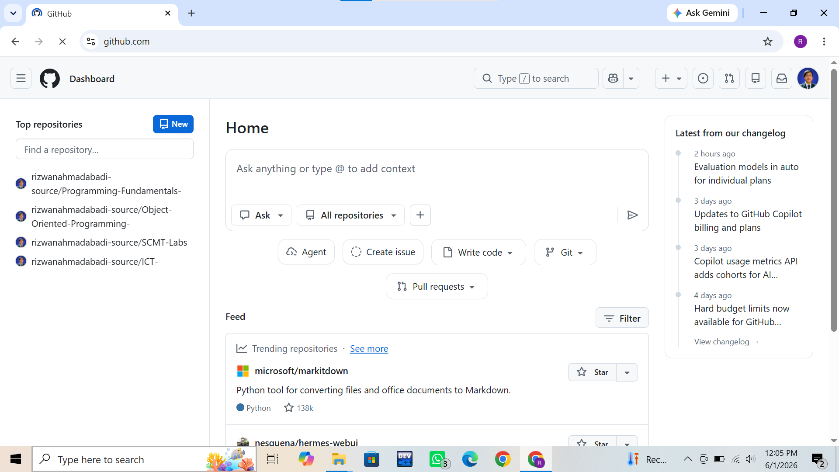

Step 2: Accessing the New Repository Option
Clicked on the "+" icon and selected the "New Repository" option, and entered repository details and configured the repository as Public.
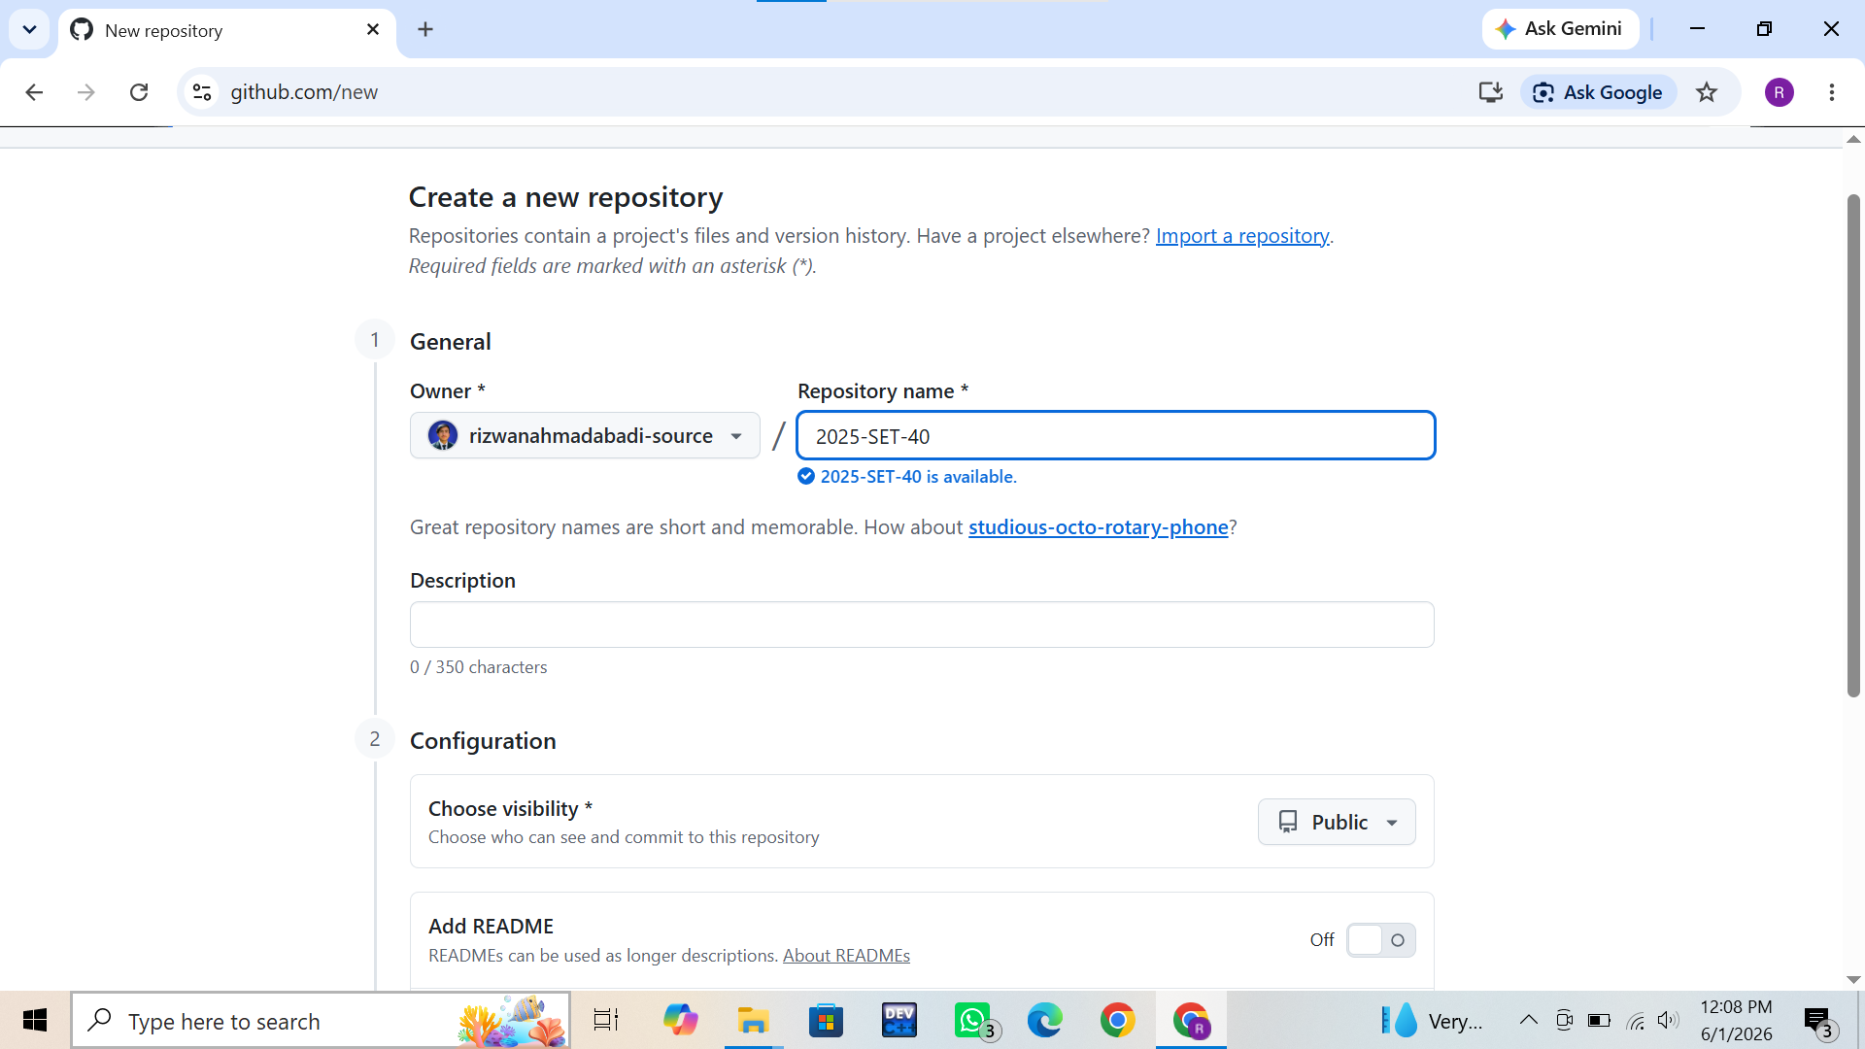
Step 3: Creating a Local Project Folder
Created a new folder named "2025-SE-026" on the Desktop.


Step 4: Opening the Folder in Visual Studio Code and Initializing a Git Repository
Opened the local project folder in Visual Studio Code And : Executed the git init command to initialize the local Git repository. (git init):
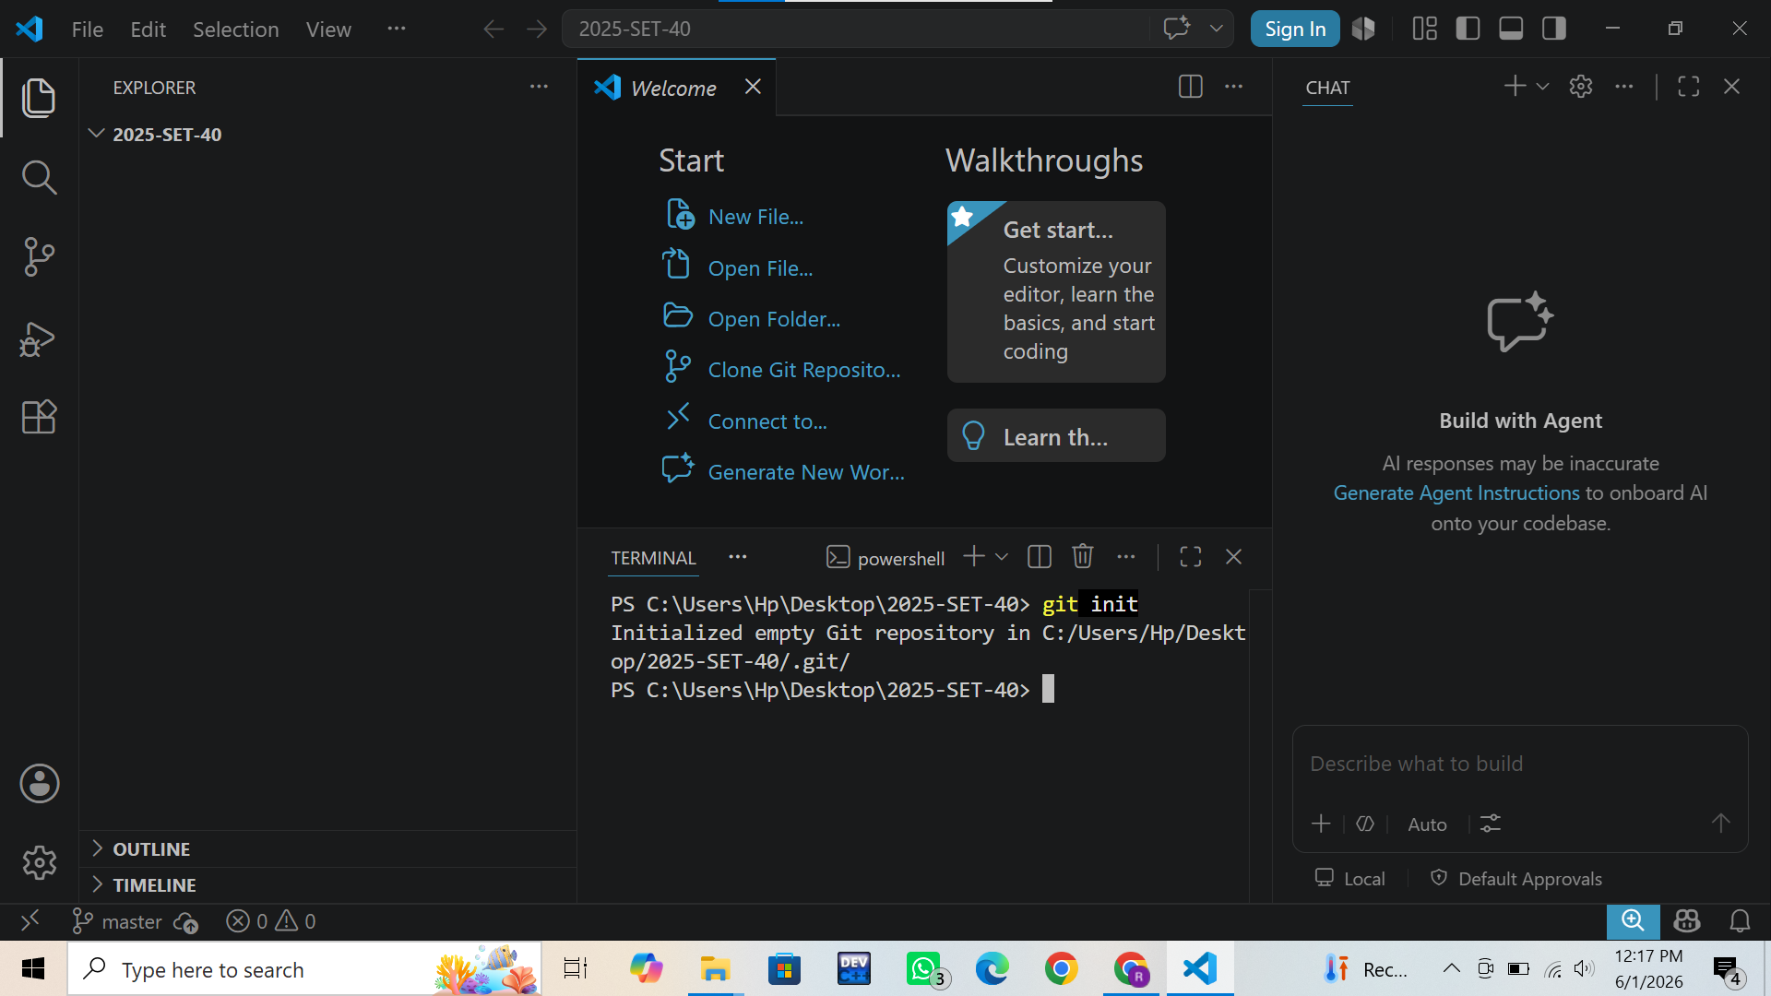
Step 5: Connecting the Remote Repository
Connected the local repository with the GitHub repository and verified the remote :
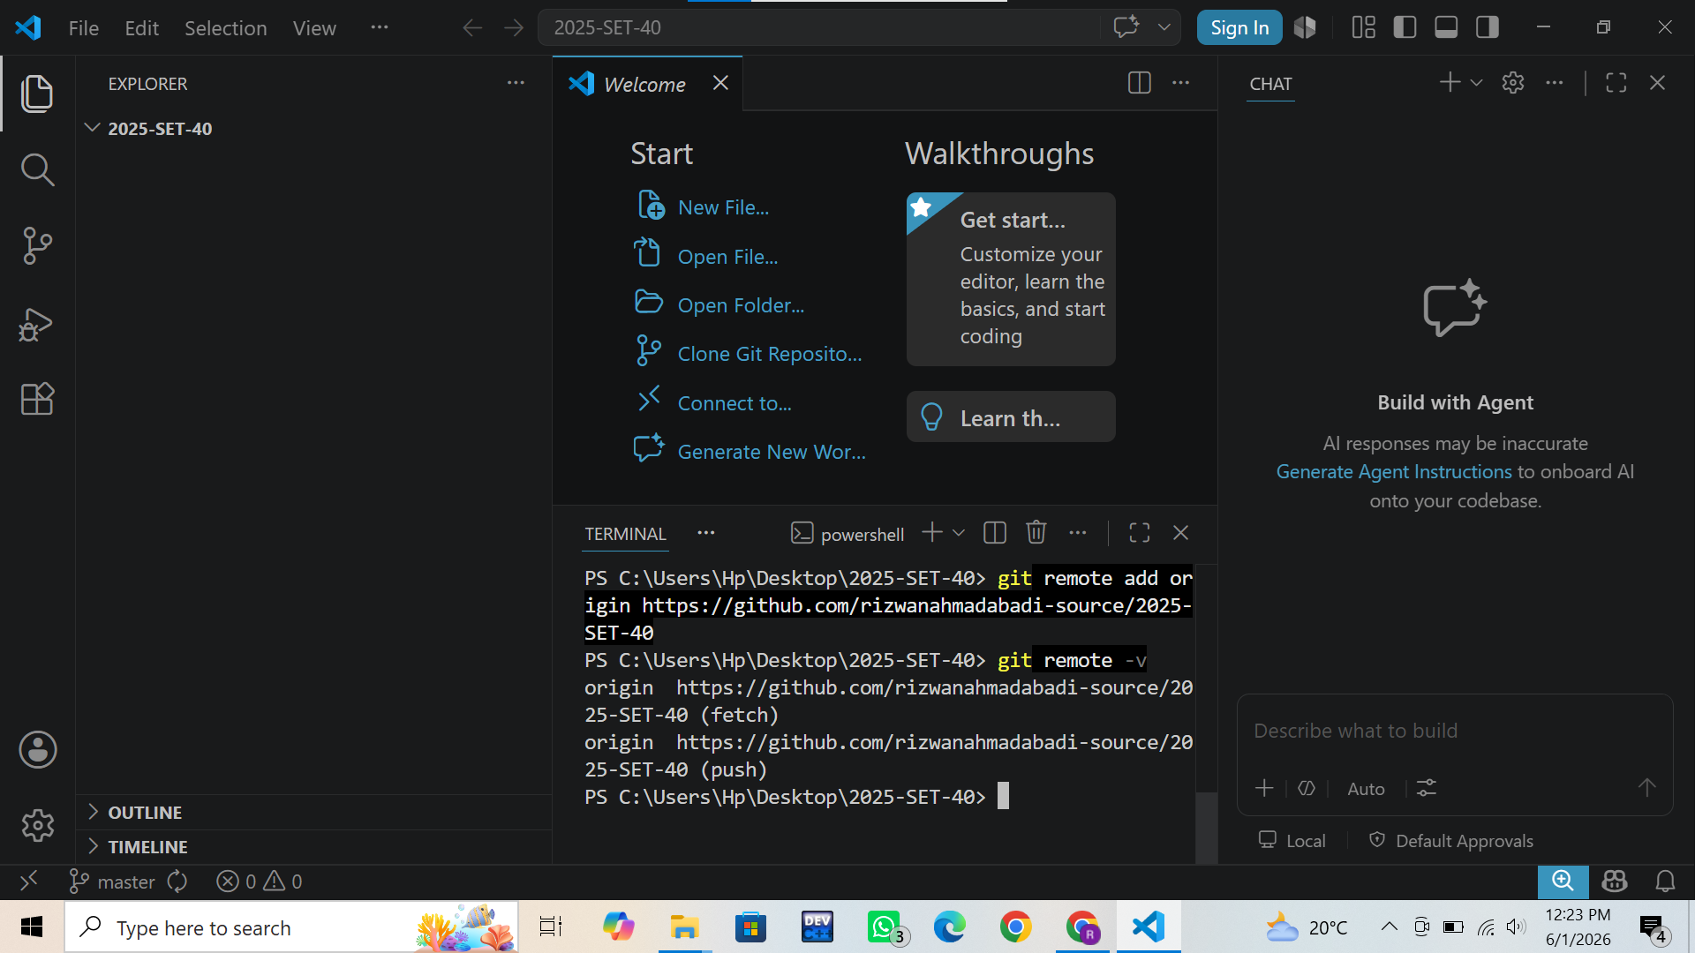
Description: Connected the local repository with the GitHub repository and verified the remote
Step 6 : Cloning a Public Repository and Viewing Commit History
The public GitHub repository octocat/Hello-World was successfully cloned After cloning, the terminal was navigated to the cloned repository using the cd Hello-World command. Finally, the git log --oneline command was executed to display the commit history of the repository
Commands Used:
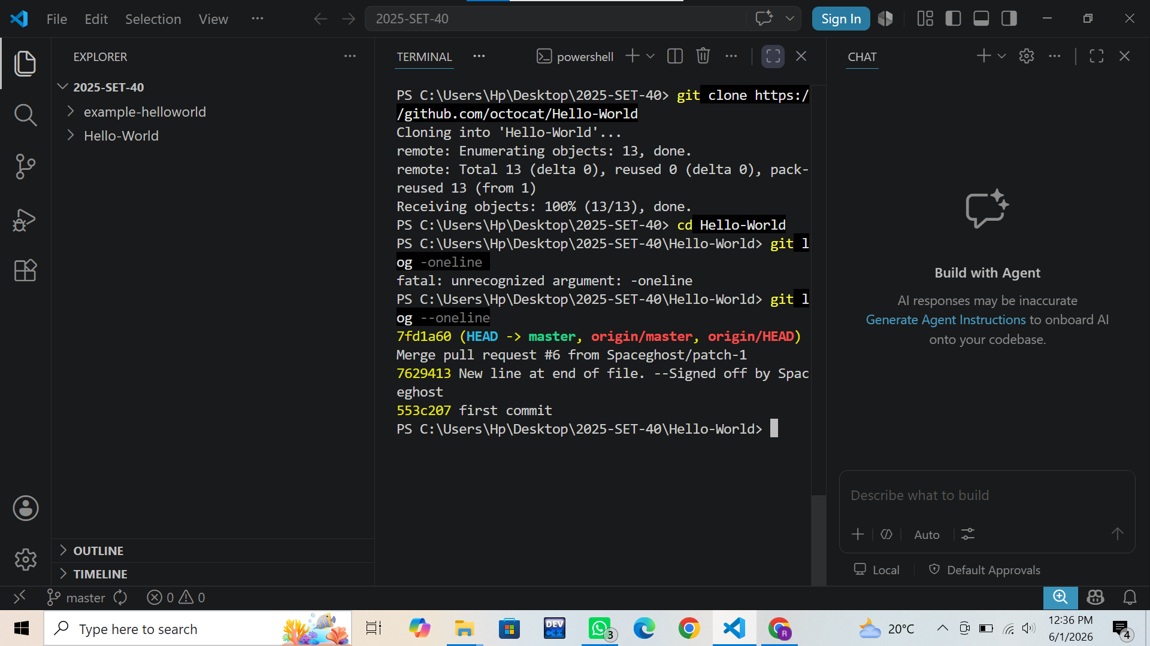
- git clone https://github.com/octocat/Hello-World.git 2) cd Hello-World 3) git log --oneline

